ML PROJECT REPORT
Title Of Project: To Detect and Recommend Solutions for Cyberbullying and Toxic Comments
Group Members of Mini Project:
1. Atharva Harane - 15
2. Darsh Kamble - 23
3. Altamash Chougle - 05

Theory:

Problem Statement:

With the rise of social media platforms like Instagram, Twitter (X), Facebook, and YouTube, toxic comments and cyberbullying have become serious concerns, affecting mental health and online safety. Existing moderation techniques often fail to detect context-specific abusive language, slang, or hidden offensive words. Moreover, even if abusive comments are detected, simply removing them may distort conversations. Hence, there is a need for a system that not only detects toxic or abusive comments in real-time but also intelligently replaces offensive words with neutral alternatives, preserving the original meaning of the sentence.

Concept / Overview:

The proposed system leverages Google’s BERT (Bidirectional Encoder Representations from Transformers), a state-of-the-art deep learning language model, to identify toxic or abusive language in user-generated content. BERT’s contextual understanding allows the system to detect not just direct abusive words, but also subtle, hidden forms of cyberbullying. Once detected, the system replaces these toxic words with non-offensive, meaningful alternatives to maintain the sentence’s semantic integrity. The model is trained on large-scale datasets of real-world comments collected from social media platforms. This ensures that the system adapts to slang, regional language, and diverse comment patterns.

Key Features:

Real-time Toxic Comment Detection: Instantly flags offensive words or phrases in comments.

Context-Aware Word Replacement: Replaces abusive words with neutral alternatives while preserving sentence meaning.

Social Media Data Training: Uses datasets sourced from Instagram, Twitter, Facebook, and YouTube comments for robustness.

BERT-based NLP: Employs deep learning with transformer architecture for high accuracy in detection.

User-Friendly Output: Displays clean, meaningful sentences without toxic elements.
- Mobile-Friendly Interface: Works seamlessly on smartphones for accessibility on the go.
- Unlimited Access to Detection & Recommendation: Users can continuously use the system without restrictions.
- Low Data Consumption: Optimized for requiring less mobile data, making it efficient for regions with limited internet connectivity.

Scalability: Can be integrated with multiple social media platforms or comment sections.

Tech Stack:

Frontend: HTML, CSS, JavaScript (for UI and display of comments)

Backend: Python (Flask / Django for API services)

Machine Learning / NLP: Google BERT (for toxic comment detection & replacement)

Dataset: Social media comments (Instagram, Twitter, Facebook, YouTube)

Libraries & Tools: TensorFlow / PyTorch, NLTK, Pandas, NumPy, Matplotlib

Database: MySQL / MongoDB (for storing user comments & predictions)

Flowchart:

Cyberbullying & Toxic Comments Detection:

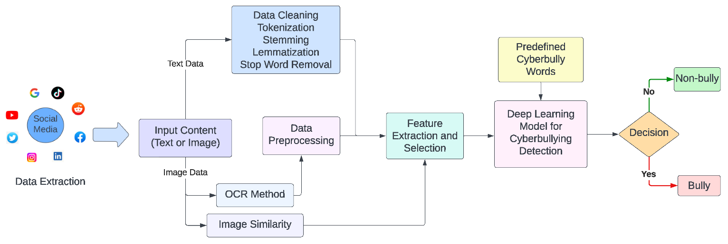

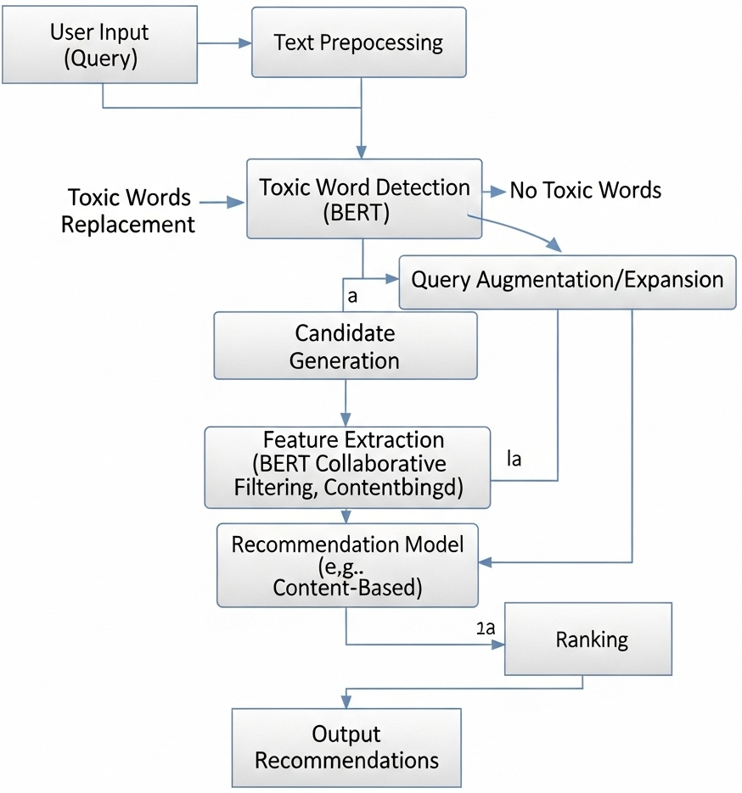
Recommendation for Cyberbullying and Toxic Comments:

Applications:

Automated moderation in social media comment sections.

Integration with chat applications for real-time filtering.

Educational forums and online classrooms to prevent cyberbullying.

Corporate communication tools (e.g., Slack, Teams) to maintain professionalism.

Use in gaming communities where toxic behaviour is widespread.

Use Cases:

A YouTube video receives thousands of comments; the system automatically filters toxic ones and shows clean versions.

A child on a gaming platform is protected from offensive messages through automatic word replacement.

Companies use it in internal chat platforms to maintain a respectful and harassment-free environment.

Online learning platforms prevent bullying in discussion forums.

Advantages:

High Accuracy: BERT’s deep contextual understanding increases detection accuracy compared to traditional ML models.

Context Preservation: Unlike simple removal, replacement maintains sentence meaning.

Real-time Processing: Efficient enough to handle fast social media comment flows.

Adaptability: Can learn from new slang and abusive patterns.

Better Online Safety: Protects users from emotional harm and encourages positive communication.

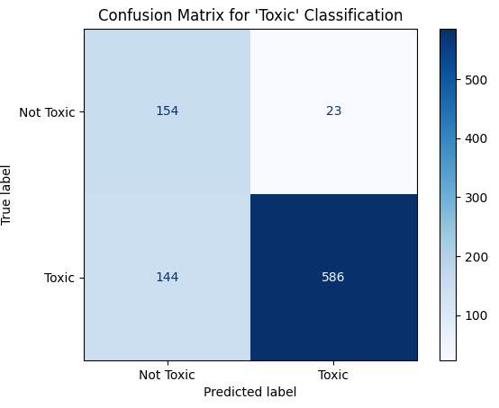
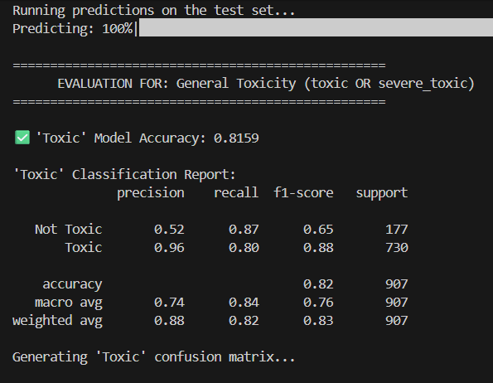
Results:
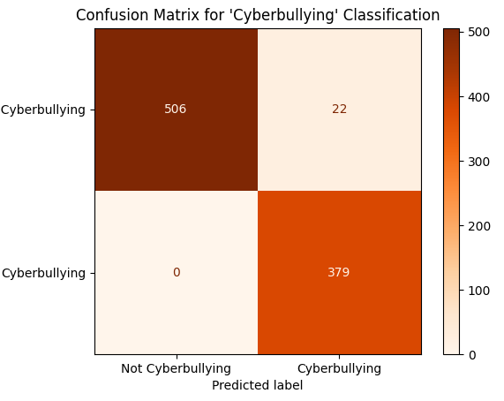
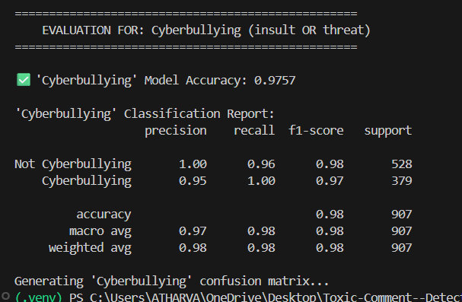

Output:




Conclusion:
The proposed system successfully detects and mitigates cyberbullying and toxic comments using Google’s BERT model, which provides high accuracy in understanding the context of language. Unlike traditional approaches that simply remove offensive content, this system intelligently replaces toxic words with neutral alternatives while preserving the overall meaning of the sentence. By training on real-world social media comments, the model adapts well to diverse linguistic styles, slang, and hidden abusive expressions. The solution not only improves online safety but also ensures smooth, respectful communication across digital platforms. With scalability and real-time performance, the system can be integrated into various applications such as social media, educational forums, gaming communities, and corporate communication platforms, making it a powerful tool in combating online harassment and promoting healthier digital interactions.

